Ocean Safety Copy
Keep your whole gang safe with these ocean safety tips.
Florida’s beaches are a glittering playground made of sun and sand -- and by all means you should enjoy the water!
You can splash in the shallows, ride the waves, or just bob up and down in the surf.
But before you dip one toe in the ocean, make sure you know these simple ocean swimming safety rules to keep you safe.
- Understand what beach flags mean.

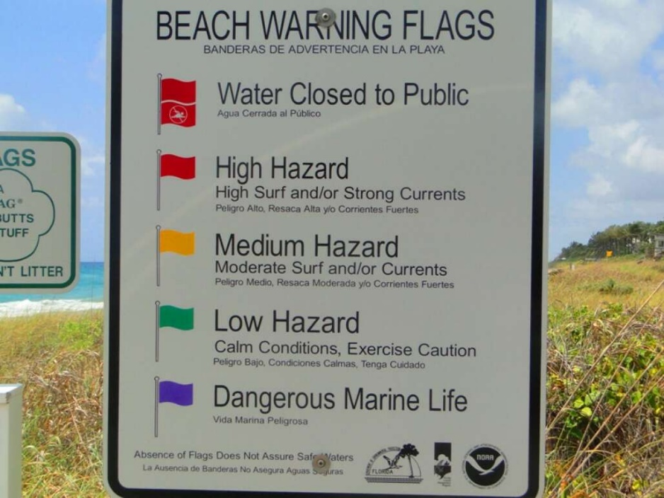

Florida’s beach warning flag program uses flags in four colors accompanied by interpretive signs along the beach to explain the meaning of each color. These ocean safety tips should be observed by everyone going to the beach.
- Double Red: Danger! Water Closed to Public
- Single Red: High Hazard, High Surf and/or Strong Currents
- Yellow: Medium Hazard, Moderate Surf and/or Currents
- Green: Low Hazard, Calm Conditions, Exercise Caution
- Purple: Dangerous Marine Life (Usually Jellyfish)
An absence of beach flags doesn’t guarantee that it’s safe. Remember to use your own good judgment.

- Shuffle your feet when you walk in the water.
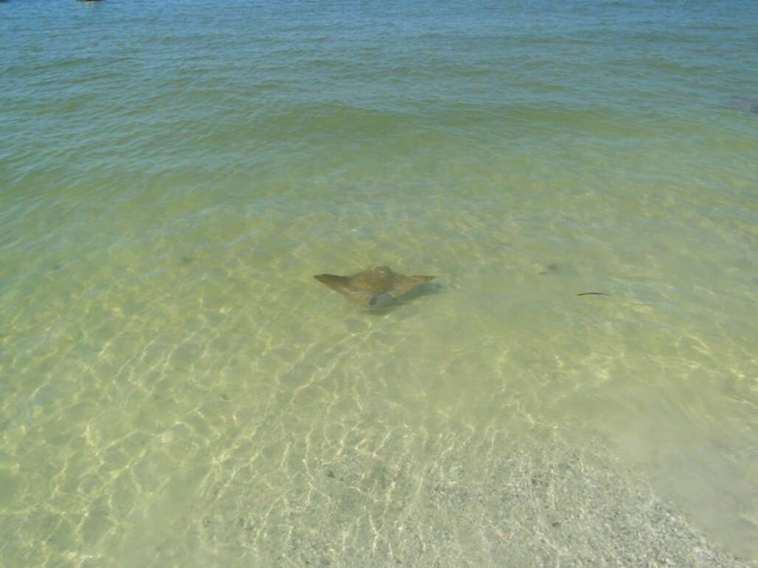

Stingrays bury themselves in the sand, often in water that’s only inches deep. They only sting in self-defense, so doing the ‘stingray shuffle’ will give them the chance to flee -- something they are happy to do.
- Know how to get out of a rip current.
These powerful, fast-moving channels of water typically flow from the shoreline to beyond the area where waves break. They can form on any beach where waves are breaking, often near sandbars, jetties, and piers. If you are caught in one, NOAA recommends these ocean swimming safety rules:

- Keep calm. Don't fight the rip current.
- To get out of the rip current, swim sideways, parallel to the beach. This will get you out of the rip current so you can swim back in with the waves helping you along.
- When out of the rip current, swim at an angle away from the rip current and toward shore.
- If you can't escape this way, try to float, or calmly tread water. Rip current strength eventually weakens offshore. When it does, swim away from the rip current toward shore.
- If at any time you are unable to reach the shore, draw attention to yourself: face the shore, wave your arms, and yell for help.

4. Locate the lifeguards.
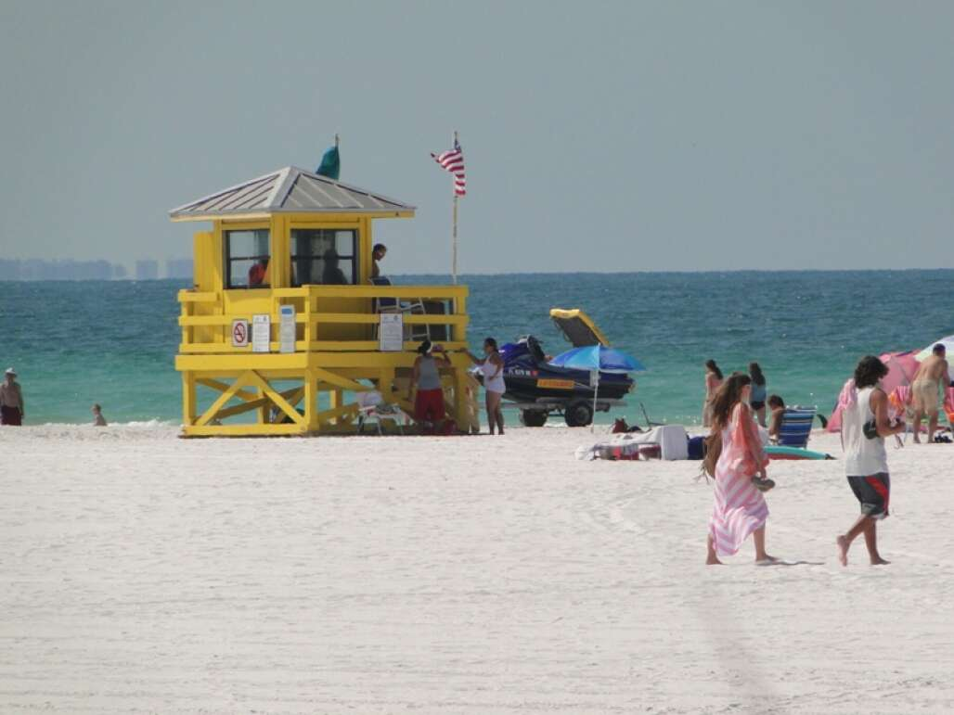
To maximize your ocean swimming safety, it’s always better to swim to near a lifeguard.

5. Beware of lightning.
Lightning in Florida is a real danger. That goes double on the beach. If you hear thunder, get off the beach. The thunderstorms that tend to pop up on summer afternoons usually pass quickly, so you can probably get back to enjoying the outdoors soon.

